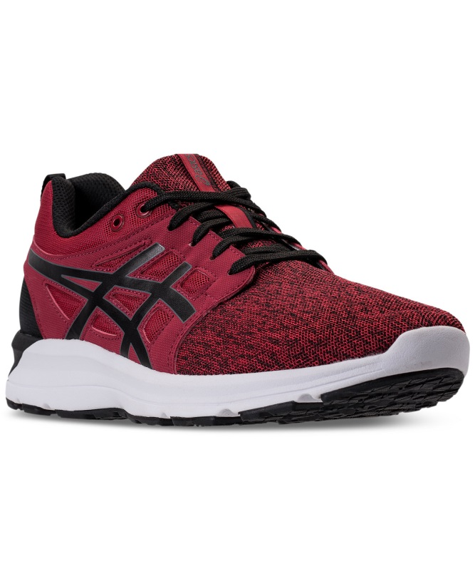 **Item**: [https://www.macys.com/shop/product/asics-mens-gel-torrance-running-sneakers-from-finish-line?ID=5043984&CategoryID=55822&selectedSize=#fn=sp%3D1%26spc%3D1725%26ruleId%3D78|BS|BA%26slotId%3D39](https://www.macys.com/shop/product/asics-mens-gel-torrance-running-sneakers-from-finish-line?ID=5043984&CategoryID=55822&selectedSize=%23fn=sp%3D1%26spc%3D1725%26ruleId%3D78|BS|BA%26slotId%3D39)  
  
Men's GEL-Torrance Running Sneakers from Finish Line

|  |  |  |  |
| --- | --- | --- | --- |
| ### | Name | ID | XPath |
| 1 | “Shopping bag” button | itemInfo | //*[@id="itemInfo"] |
| 2 | Product title | N/A | //*[@id="productHeaderBox"]/div[1]/div/div/div/div/h1 |
| 3 | “Customer also shopped” block | verticalPros | //*[@id="verticalPros"] |
| 4 | “Regular price” text field | N/A | //*[@id="productHeaderBox"]/section[2]/div/div[1]/span |
| 5 | “Color” text field | N/A | //*[@id="orderPanel5043984"]/div[1]/div/div/span[2] |
| 6 | “Add to bag” button | N/A | //*[@id="orderPanel5043984"]/div[4]/div[1]/div[2]/button/span |
| 7 | “Add to list” button | N/A | //*[@id="orderPanel5043984"]/div[4]/div[1]/div[3]/div/label |
| 8 | Images column | altImages | //*[@id="altImages"] |
| 9 | “Reviews” button | N/A | //*[@id="bottomTabs"]/div[1]/ul/li[1] |
| 10 | “Product Q&A” button | N/A | //*[@id="bottomTabs"]/div[1]/ul/li[2] |
| 11 | “Customer pictures” button | N/A | //*[@id="bottomTabs"]/div[1]/ul/li[3] |
| 12 | “Sign In” button | globalMastheadSignIn | //*[@id="globalMastheadSignIn"] |
| 13 | Popular searches | tagCloud | //*[@id="tagCloud"] |
| 14 | “Stay connected” links | stayconnected | //*[@id="stayconnected"] |
| 15 | “News in Macy`s” links | media | //*[@id="media"] |

Some visible elements and their ids(if exist) and XPaths

Elements validation

|  |  |  |
| --- | --- | --- |
|  | Name | Shapshot |
| 1 | “Shopping bag” button |  |
| 2 | Product title |  |
| 3 | “Customer also shopped” block |  |
| 4 | “Regular price” text field |  |
| 5 | “Color” text field |  |
| 6 | “Add to bag” button |  |
| 7 | “Add to list” button |  |
| 8 | Images column |  |
| 9 | “Reviews” button |  |
| 10 | “Product Q&A” button |  |
| 11 | “Customer pictures” button |  |
| 12 | “Sign In” button |  |
| 13 | Popular searches |  |
| 14 | “Stay connected” links |  |
| 15 | “News in Macy`s” links |  |